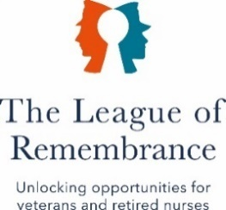

ANNUAL REPORt AND ACCOUNTS
2025
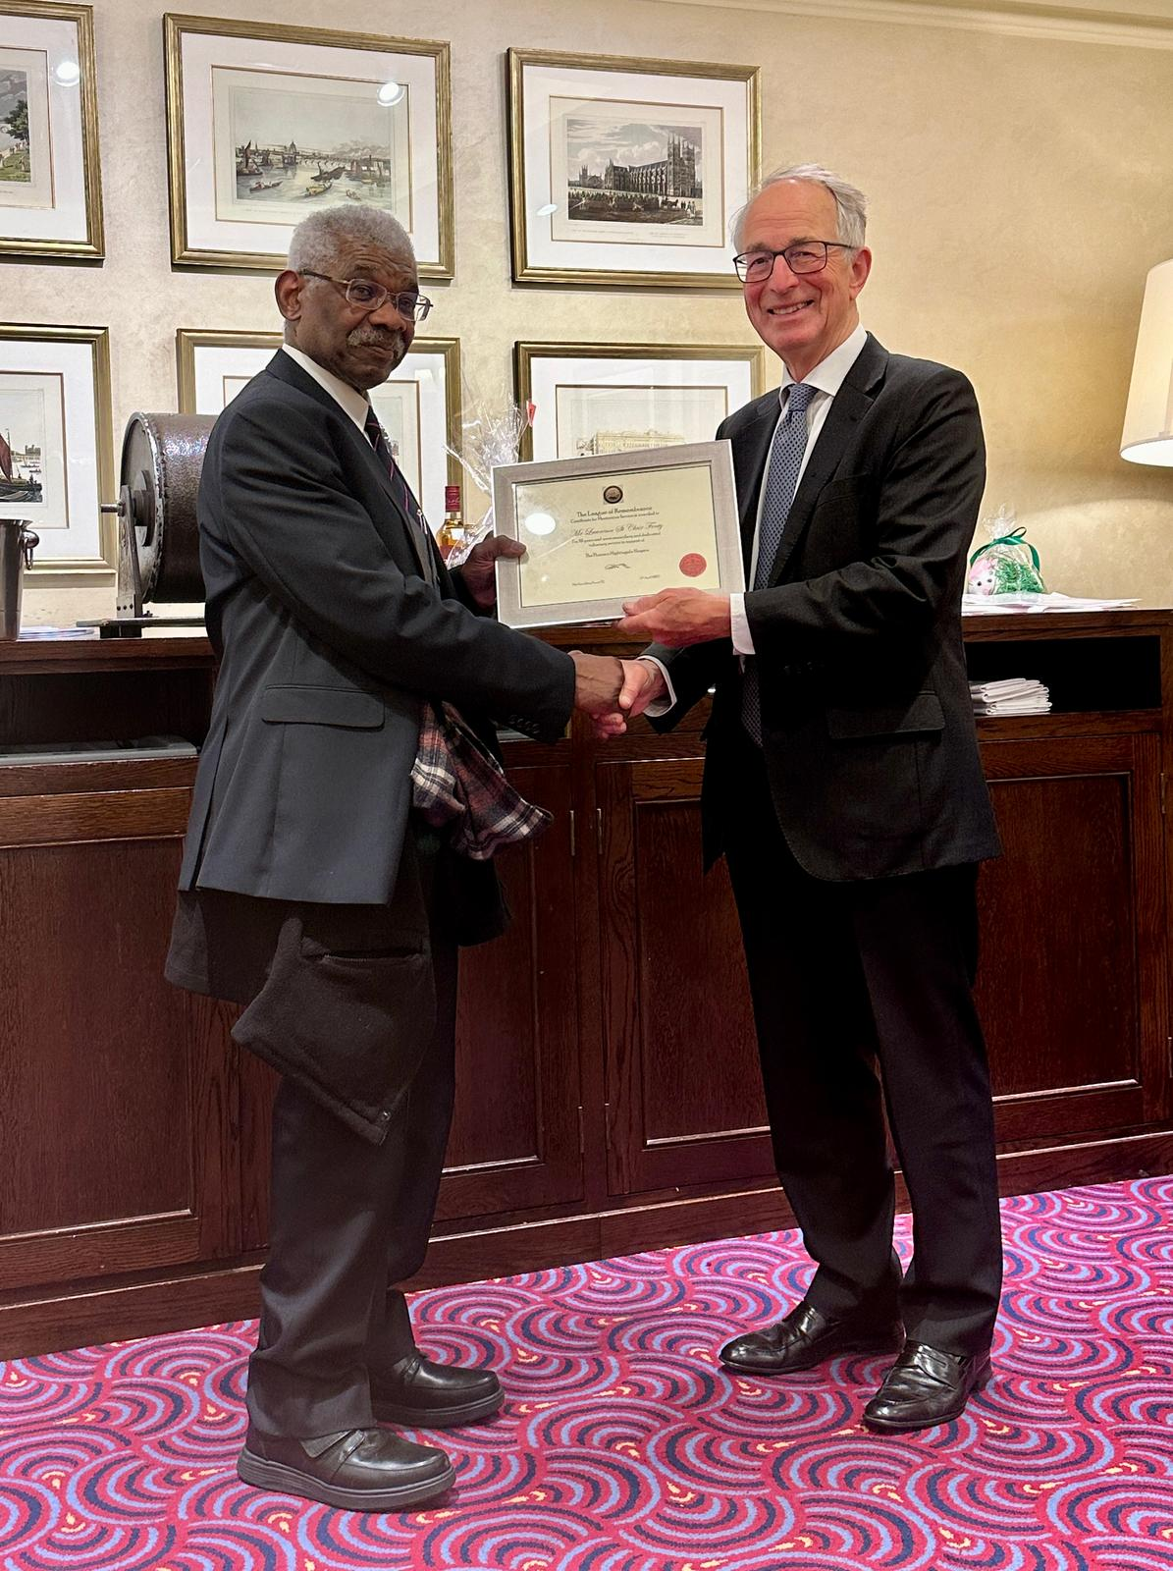

are

“Meritorious Service Presentation To A Fellow Royal Artilleryman”
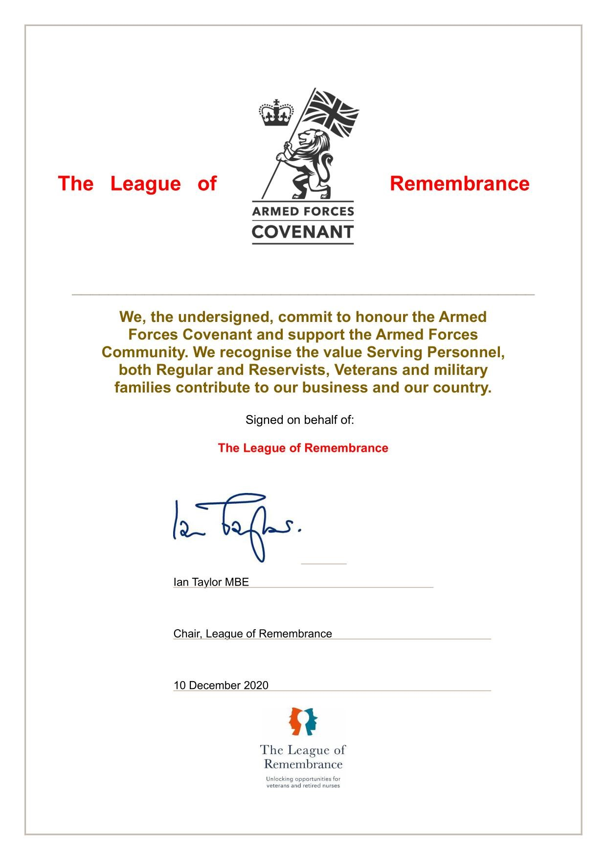
r fa are “Proud To Support the Covenant”
CONTENTS

Foreword By Our Chair | 4
Overview of Our Services and Administration | 5
Structure, Governance and Management | 6 - 7
Our Trustees’ Report | 8 - 25
Independent Examiner Report | 26 -

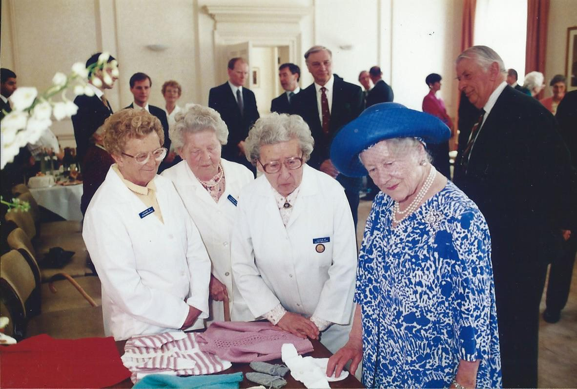
“The Queen Mother – 1980’s”

FOREWORD

As we stride confidently into 2026, I am able to look back with immense pride over our achievements during the current reporting year, particularly as it has also been a year to celebrate.
Firstly, I must, on behalf of the ‘League Family’, congratulate our Patron, Lord Richards, on his elevation in the recent Kings Honour Awards, to the rank of honorary Field Marshal. This appointment was made in well-deserved recognition of his most distinguished service and continued support to the United Kingdom, realms, and territories.
Lord Richards has been an integral part of The League of Remembrance for a considerable number of years and, during this time, has served us with unwavering resolve. We should like to extend our congratulations once again, and hope that we may look forward to enjoying his valued friendship and support for many more years to come.
Secondly, it is 110 years since we were formally established as a charity under the guidance and leadership of Princess Beatrice. Since then, we have supported many thousands of individuals and institutions, and continued to benefit from the patronage of other members of the Royal Family, including Field Marshal HRH The Duke of Connaught KG, HRH The Dowager Marchioness of Milford Haven, HM Queen Mary, and HM Queen Elizabeth The Queen Mother. Wonderful support indeed, and very much appreciated.
In other news, Philippa Clare, our Vice-Chair, who joined us in 2016, left us to develop a new and exciting business venture. She will be missed, and we extend our very best wishes to her for the future. Our new Vice-Chair is Chris Eberhardie, somebody with strong military and nursing connections, and who has made a flying start in the role. We are also actively ‘recruiting’ additional Trustees and we hope to welcome additional talent to the Board soon.
In last year’s report I detailed our new strategy, and how it was developing. This year we have renewed our pledge to help those suffering from disability or illness, whilst concurrently maintaining and improving support to our traditional Remembrance Workers. For our Remembrance Workers we were able to deliver an uplift in our financial grant-in-aid support, something that has been much appreciated, particularly at a time of rising living costs. This was possible both due to the generosity of our donors, and our sensible Reserves Policy. Our welfare and social event support continues undiminished.
In terms of our commitment to assist those suffering from disability or illness, our relationship with Level Best has gone from strength to strength. We pay regular visits to see those disabled adults we are supporting, and it is heartening to see the positive impact our support has. We have also purchased boccia equipment for use by disabled adults, with funds raised during our AGM/Spring Lunch raffle and have pledged to support a young lady suffering from loss of mobility and independence. We will deliver further support as we identify deserving needs.

Once again, fundamental to our success has been the loyalty and selfless commitment of our Remembrance Workers; my fellow Trustees and core team; the organisations that welcome our volunteers; and last, but not least; our wonderful donors for their incredible ongoing support. Our foundations continue to strengthen, our resolve remains as steadfast as ever, and we will meet, head-on, the challenges of 2026, and beyond, with confidence and optimism.

Thank you, one and all.

Geraldine Norris DL
OVERVIEW OF OUR SERVICES

The League of Remembrance provides enduring and practical support to our Armed Forces veterans, their widows, and dependants, and to retired nursing staff; and, in support of our secondary charitable object, we are also able to support those individuals suffering from sickness or disability. We began our work in 1915 and are proud that now, as we progress through our second 100 years of service to the community, we look to continue and expand our operations.

ADMINISTRATION

CONTACT  95 Horseferry Road  LONDON  SW1P 2DX  07936 505664  INFORMATION  info@leagueofremembrance.com  www.leagueofremembrance.org.uk  @LofR1915  https://www.facebook.com/leagueofremembrance  REGISTERED CHARITY NUMBER  213364  COMPANY REGISTRATION NUMBER  00171814 | AUDITOR  Kreston Reeves  9 Donnington Park  85 Birdham Road  CHICHESTER  PO20 7AJ  BANKER  Metro Bank  1 Southampton Row  LONDON  WC1B 5HA  INVESTMENT MANAGER  CCLA  One Angel Lane  LONDON  EC4R 3AB

STRUCTURE, GOVERNANCE AND MANAGEMENT

The League of Remembrance is a Charitable Company governed by a Memorandum of Association and Articles of Association last amended by Special Resolution in 2020.
Our Chief Executive, known as the Secretary, is responsible to the Council (the Trustees) for the management of all operations, and is directly answerable and accountable to the Chair of Council. Council members are ultimately responsible for all matters concerning governance, strategic direction, legal operation, and financial probity. They are selected for the working knowledge they have of charity-related activities, and the individual skills they can contribute to the charity’s direction.
Patron

Field Marshal The Lord Richards of Herstmonceux GCB CBE DSO DL

President

Mr Ian Taylor MBE

Vice-President

Mr Geoffrey Redman-Brown MA

Chair

Ms Geraldine Norris DL

Vice Chair

Mrs Christine Eberhardie TD

Council Members

Ms Philippa Clare (resigned July 2025)
Mr Huw Dolphin
Mrs Sarah Chapman Galley

Secretary

Major Rob Thomas

Volunteer and Welfare Manager

Mrs Susan Taleghany

MEET OUR COUNCIL

Geraldine Norris DL is a Fellow of the Royal Society of Arts, Member of the Chartered Institute of Public Relations, and a Member of the Institute of Fundraising. Formerly Corporate Affairs Director EMEA of a global real estate company and Director of Operations for a national charity, she is currently Chair of Trustees of an independent school that recovers children that are so severely bullied that they self-exclude from school. She joined the First Aid Nursing Yeomanry (FANY) in 2006 and served on its Board for five years with responsibility for recruitment and fundraising, and is also a Freeman of the City of London and a Liveryman of The Worshipful Company of Farriers. Geraldine was commissioned as a Deputy Lieutenant of Greater London in 2022.

Chris Eberhardie TD is a retired general and neuroscience nurse. She gained experience in various parts of the UK and Belgium, and has also worked with national and international nursing organisations. In 1979, Chris was elected as the first Chair of the European Association of Neuroscience Nurses, and was elected Vice-President of the World Federation of Neuroscience Nurses. Her research has centred on nutrition support in Traumatic Brain Injuries.

Chris joined the QARANC Reserve in 1970, and for most of the next 30 years was in the Army Neurosurgical Team. She was awarded the Territorial (Efficiency) Decoration in 1982, the First Clasp in 1988, and the 2nd Clasp in 1994.

On retirement, Chris lived in France until the death of her husband in 2015, at which point she returned to England to start a new career in the history of military medicine, and taking up volunteering in military charities.

Chris is a Freeman of the City of London and a Liveryman of the Worshipful Company of Nurses.

Sarah Chapman Galley is Head of New Business Office at an investment bank, and a chartered management accountant with close to two decades' experience in financial services accounting, analytics, and risk management across asset classes, with a focus on FIC. As well as product expertise, Sarah has specialised in investment banking cost management, a skill which she has adapted towards her volunteering efforts in the charity and education sectors.

Sarah attended Wharton Business School's Women's Executive Leadership Programme and featured in Brummell Magazine's "Top 30 Ones to Watch" 2017, a celebration of rising stars in the City of London. Sarah champions diversity in the workplace and as a mother to two young children is passionate about being a visible mother in the City.

Huw Dolphin is a solicitor and independent director. Having been a partner in a Global Law firm, Huw set up his own consulting practice in 2023. In this guise he provides commercial, strategic, and practical advice to boards of directors, lenders and investors involved in complex legal, commercial, and financial issues. Huw also managed one of his firm’s offices, which consisted of over 150 people, for over 5 years.

Among Huw’s professional interests are the encouragement of inclusion and diversity and the promotion of social mobility in the workplace. Huw has also previously held several roles in the voluntary and charitable sectors. As a father of an autistic son Huw also has a strong interest in how neuro-diverse young adults can be valued and found opportunities to contribute in work and society.

TRUSTEES REPORT

We, the Trustees, are pleased to present the Annual Trustees’ Report and Consolidated Financial Statements of the Charity. These financial statements comply with The League of Remembrance Governing Document, the Charities Act 2022, and the Statement of Recommended Practice applicable to charities preparing their accounts in accordance with the Financial Reporting Standard applicable in the UK and Republic of Ireland (FRS 102).

OUR CHARITABLE OBJECTS

The relief of persons who are in need, hardship, or distress, or suffering from loneliness and who are either/or:

- Widows or dependants of former members (whether alive or dead) of the Armed Forces of the Crown (veterans).

- Widows or dependants of other persons who have been killed or incapacitated in or through war or civil disaster or other exceptional circumstances.

- Former members of the Armed Forces of the Crown (veterans).

- Retired members of the nursing profession.

The relief of persons in need who are sick, convalescent, disabled, or infirm by relieving their suffering or assisting their recovery.

OUR CORE SERVICES

We provide direct, practical, and enduring support to Armed Forces veterans, their widows, and families, as well as to retired nurses and other clinical staff. The people we work with have given years of service to our communities and now, perhaps nearing, or following retirement, want to continue to do this for as long as they are able. Some may also have lost their purpose in life, perhaps due to bereavement or illness. Whichever, we are there to help them to continue to feel valued and to contribute to our communities.

As a charity, with over 100 years of experience, we strongly believe that helping people fulfil a need is not just about giving them the tools to enhance their health and well-being, but about them playing a full role in the process too.

We achieve this through volunteer placements, based on the principle of ‘helping people, to help themselves, by helping others.’

VOLUNTEERING PLACEMENTS
The core of what we do is volunteering. Today we continue to provide support to 49 retired nurses and veterans, and their widows and dependants, who serve, or have served, as voluntary Remembrance Workers, helping in hospitals, hospices, and community organisations, mainly across London, but also in Buckinghamshire, Essex, and Suffolk. Our model is unique in this field, in that apart from bringing fresh purpose to their lives we both enable and direct our beneficiaries in giving of their time, skills and experience to our hospitals, hospices and other institutions, thereby returning much greater value to the community and the individual than could ever be afforded otherwise.
OUR DEVELOPING STRATEGY AND SERVICES

As part of a newly-implemented strategy, we now also support those suffering disability or recovering from illness, but with priority remaining fully focussed on the continuation of full, or improved, support to our Remembrance Workers.

Since we initiated the strategy, we have supported those organisations and individuals detailed below, and are continuing to identify, and develop relationships with, further deserving individuals and organisations.

Hampshire Footpath Project
Highground Xmas Wreath Project
Level Best Colchester
Shore Leave Haslar
Sport For Confidence
RDA Charlton Park
Warrior Equine
Wali Noori (Afghan Interpreter)

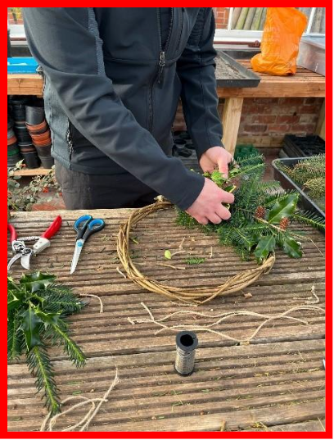
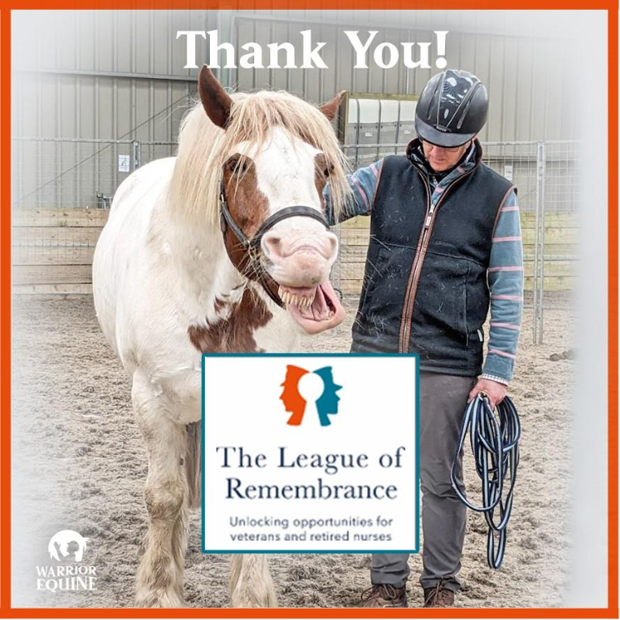
WARRIOR EQUINE HIGHGROUND



LEVEL BEST

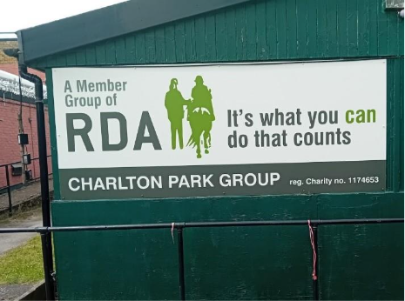
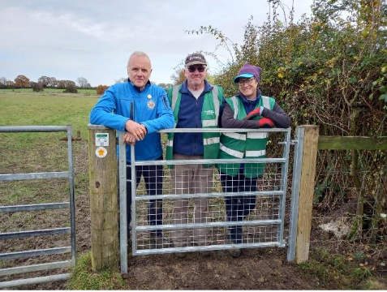
HAMPSHIRE FOOTPATH RIDING FOR THE DISABLED

OUR REMEMBRANCE WORKERS STORIES, THOUGHTS AND PICTURES
JANE’S STORY


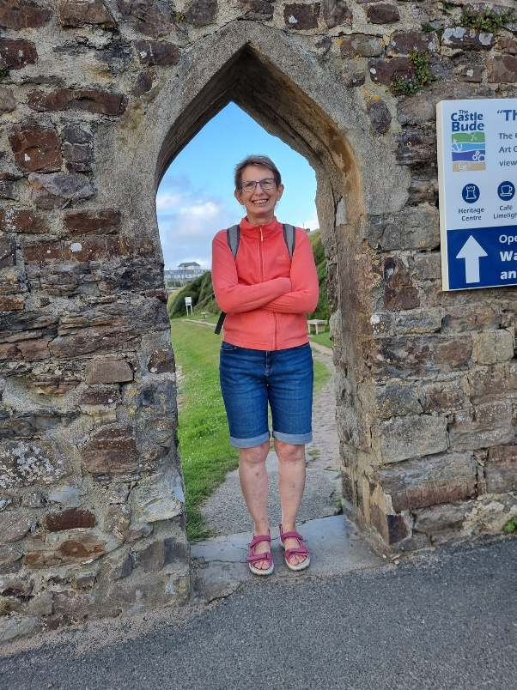
Jane joined us in May 2019, and since that time has been delivering volunteering duties at many different, and diverse, organisations. She assists the Bucks, Berks, and Oxon Wildlife Trust; helps out in local nature reserves; is part of the Waddesdon Manor gardening team; and last, but far from least, is part of the Breastfriends Aylesbury Cancer support group, where she accompanies friends, and others, to their chemo appointments, providing much-needed and appreciated support and empathy. She also enjoys outdoor activities, and keeping herself fit and well.
Well done, Jane.

CYRIL’S STORY

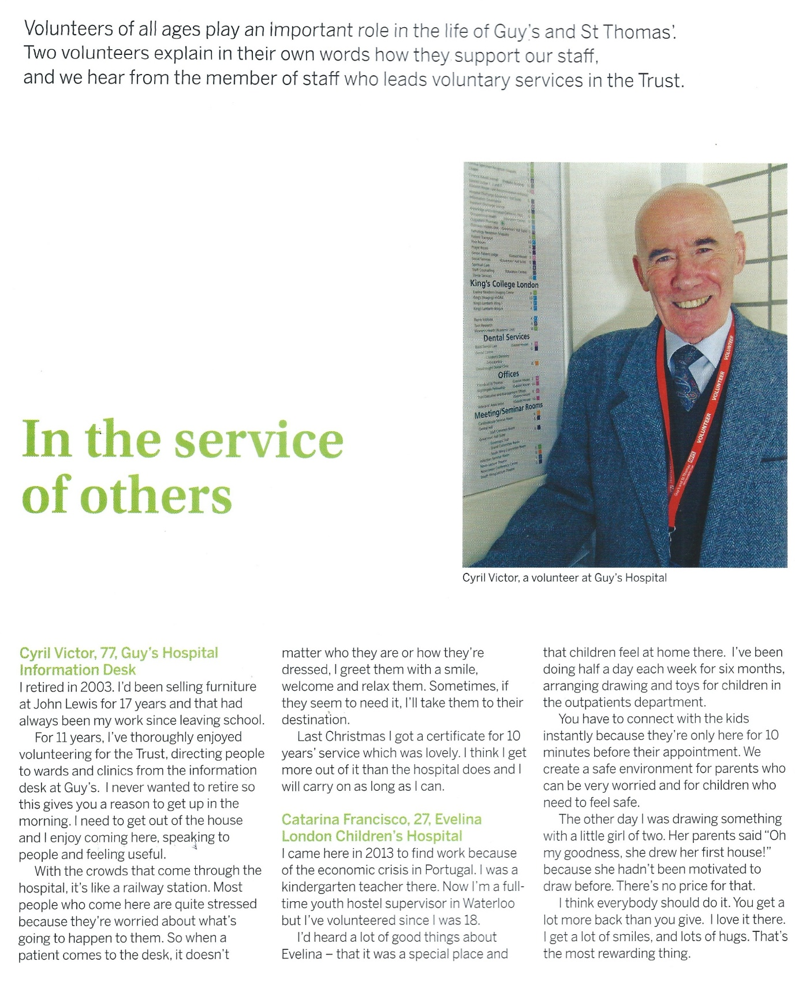

“Cyril Victor – One Of Our Stalwarts”

THOUGHTS

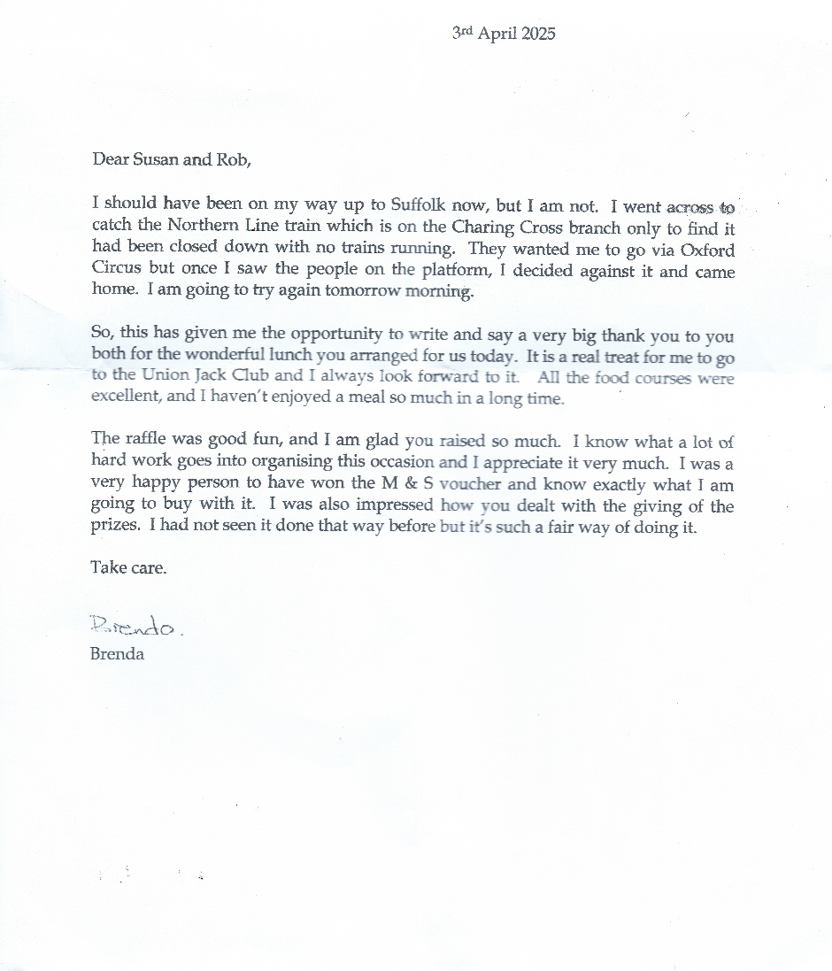

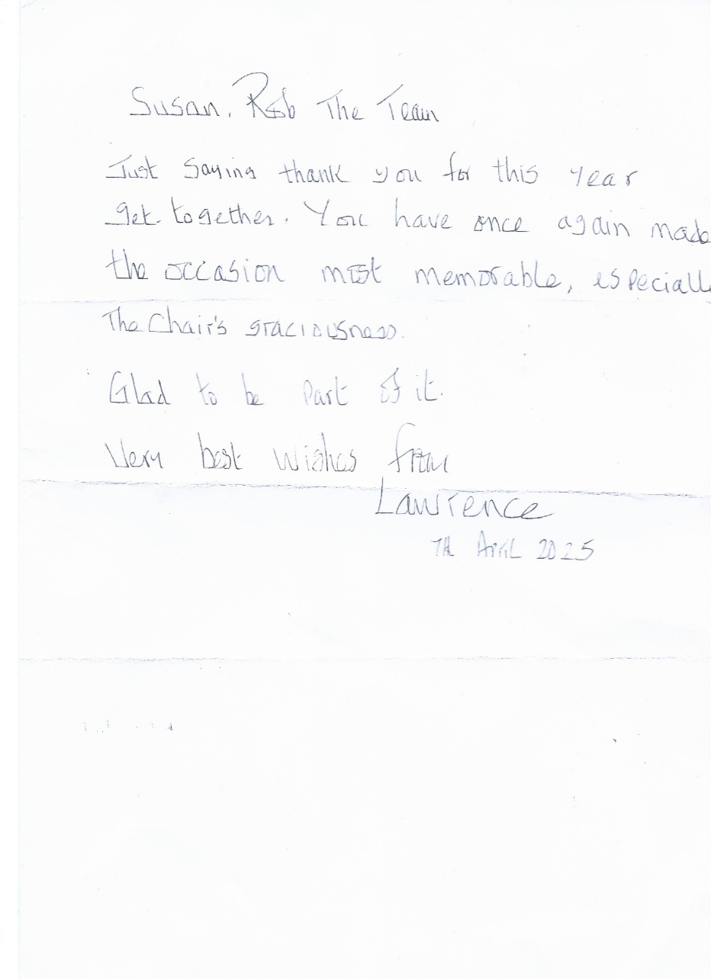

MIKE, PAT, JILL, AND WENDY – OUR WONDERFUL REMEMBRANCE WORKERS
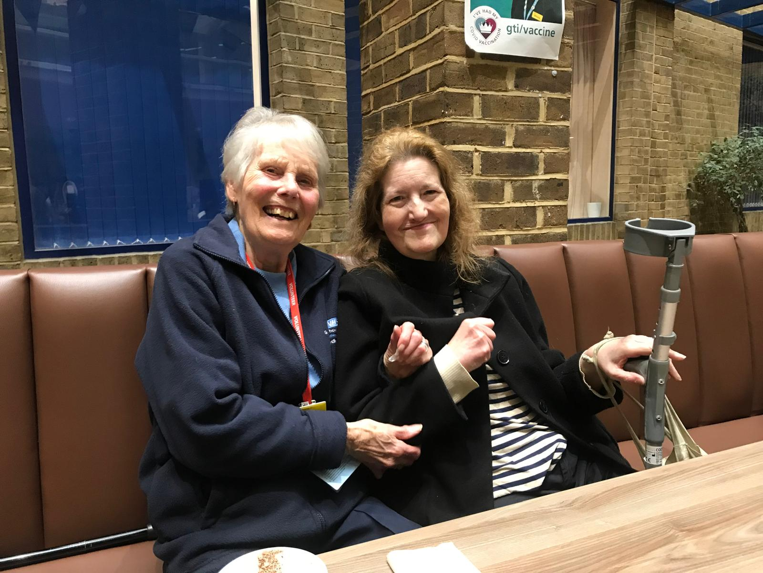
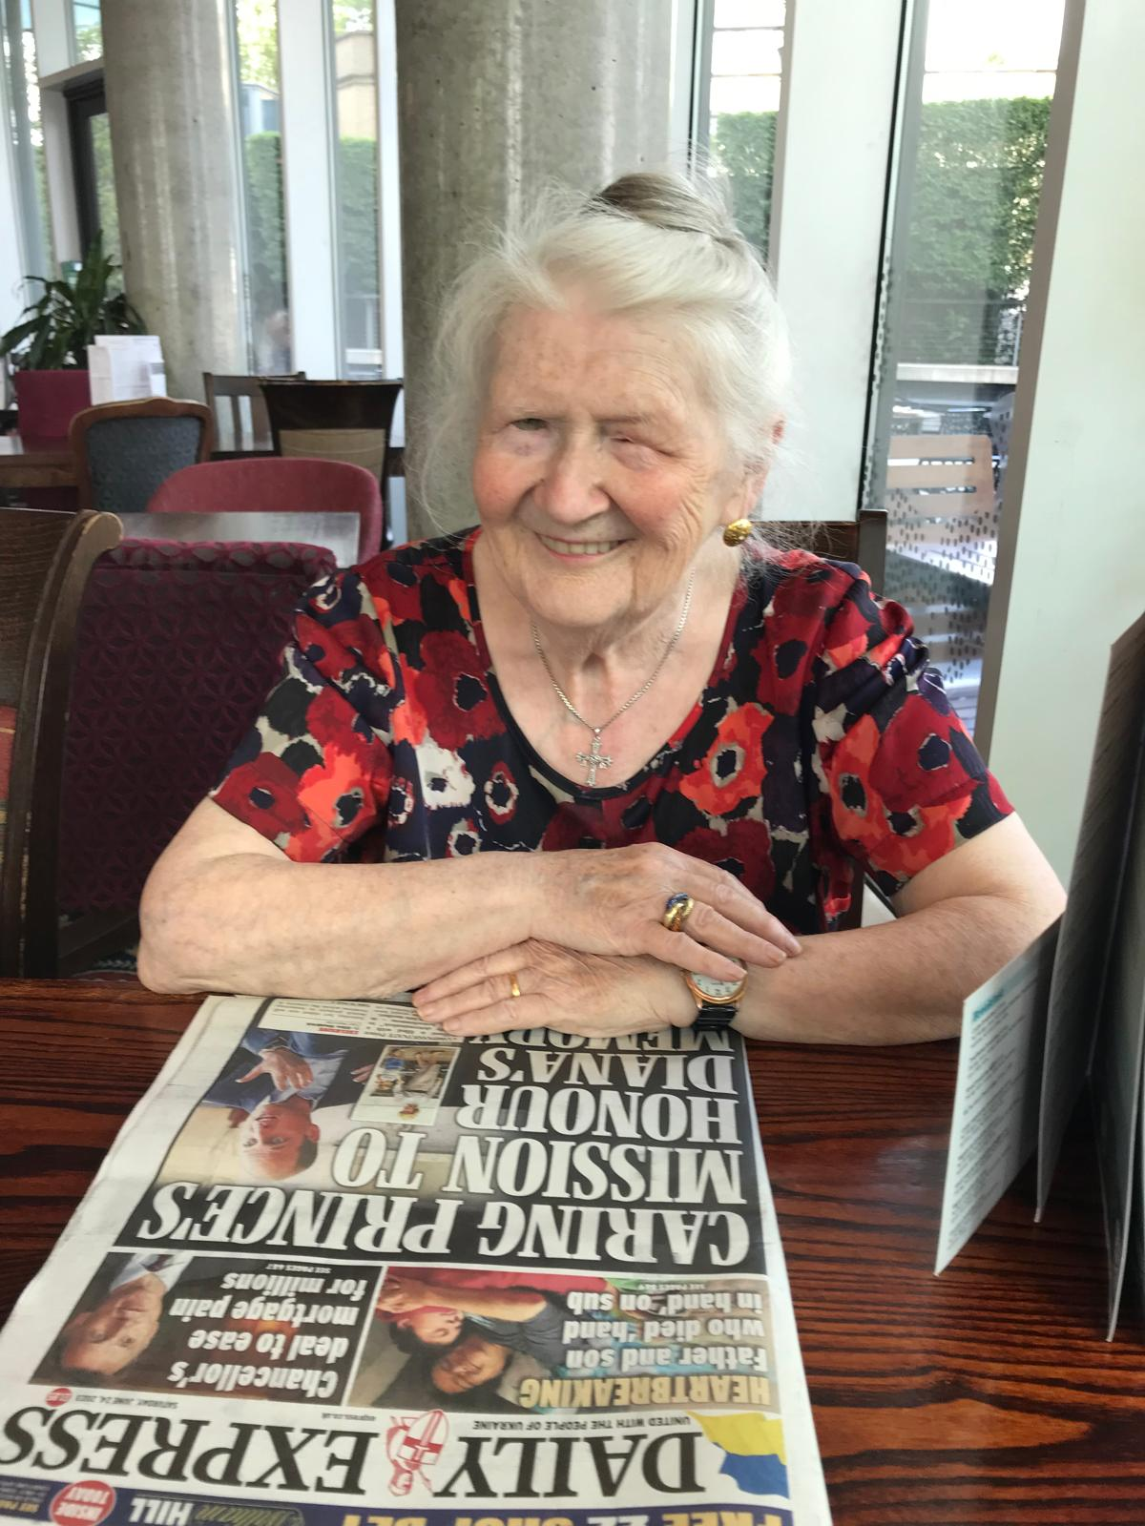
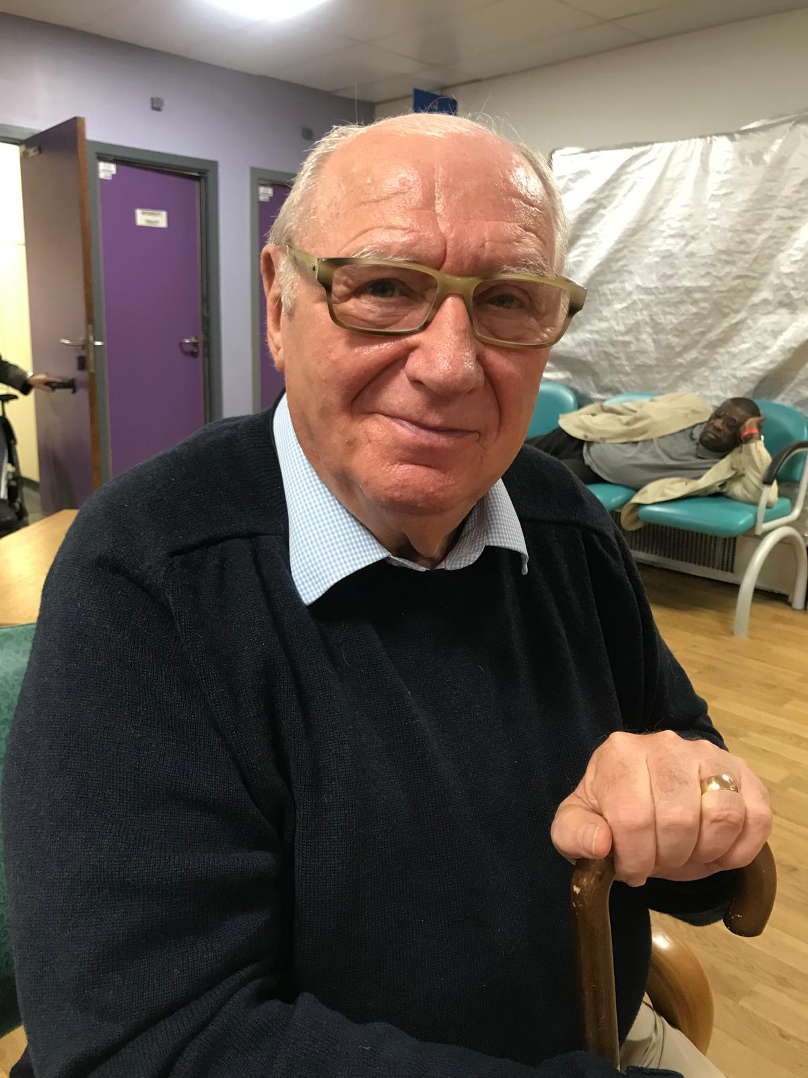
WELFARE SUPPORT

We also provide enduring support to those Remembrance Workers who, through infirmity or ill health, are no longer able to volunteer in any capacity. Our offer for these ‘Honorary Remembrance Workers’ covers everything from home visits, ensuring they are able to attend our social events, acknowledging birthdays and anniversaries, signposting to other organisations, financial support, and attendance at funerals.

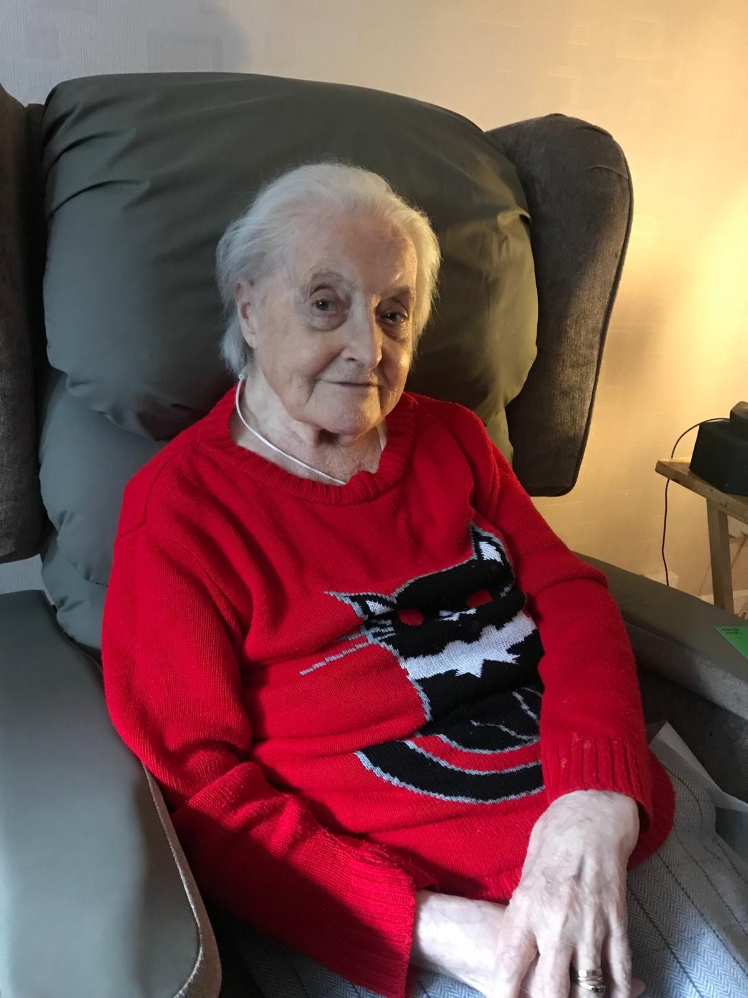

“One of Our Welfare Visits To Maureen”

SOCIAL EVENTS

Companionship, friendship, and camaraderie are what binds us all together, and at the centre of this is the provision of social events. This year we, enjoyed Xmas at events in London, Leighton Buzzard and Colchester, celebrated together at our ‘Spring Lunch, held in the Union Jack Club, and recently enjoyed a visit to the Chelsea Physic Garden.

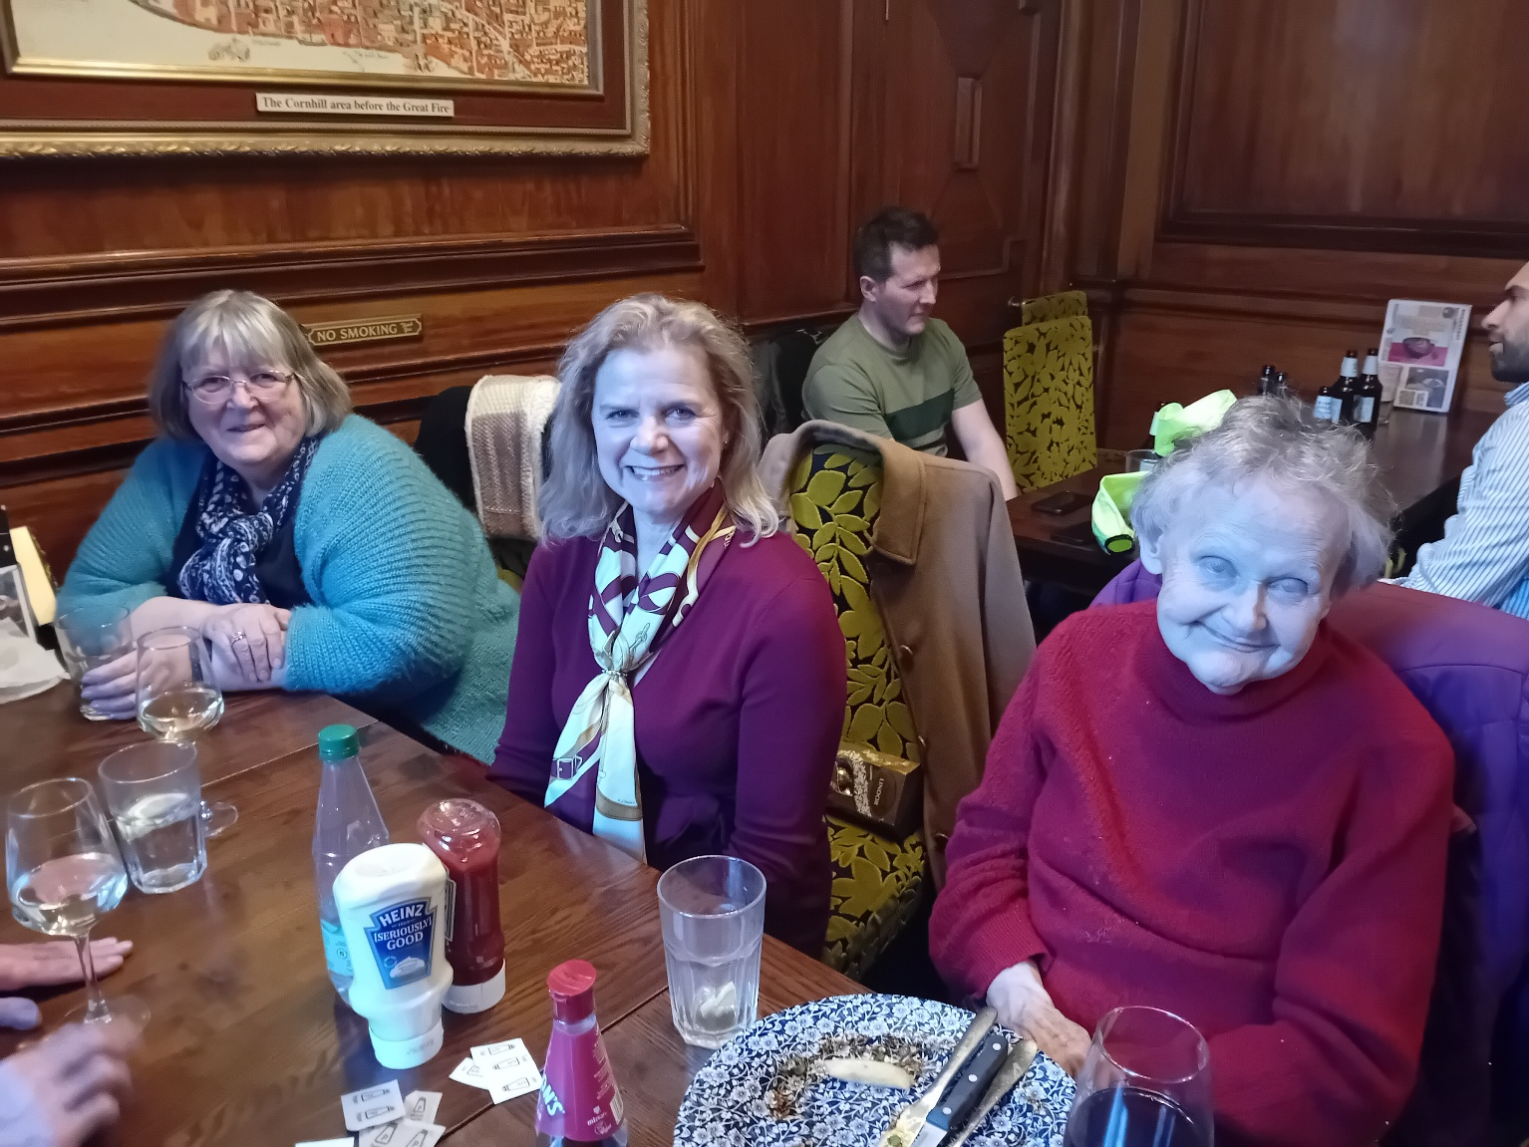
“Xmas Celebration in London”

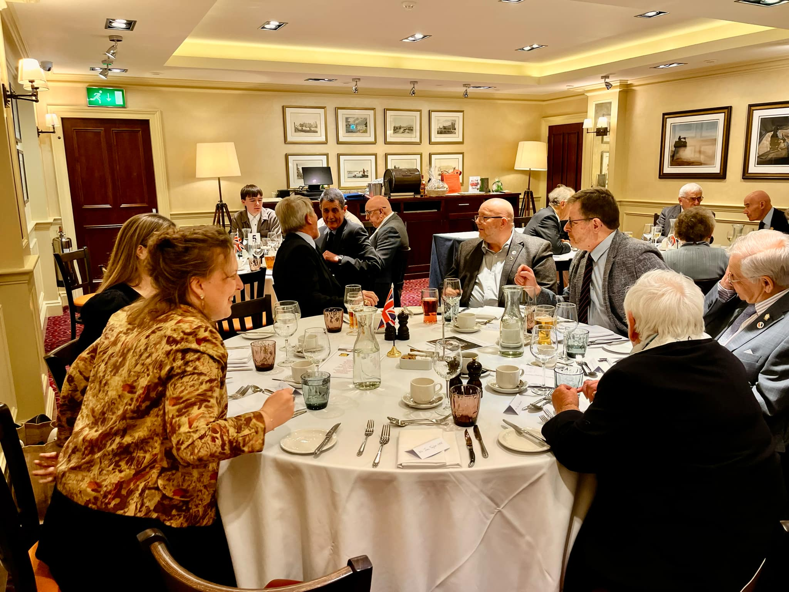

“Our AGM and Spring Lunch
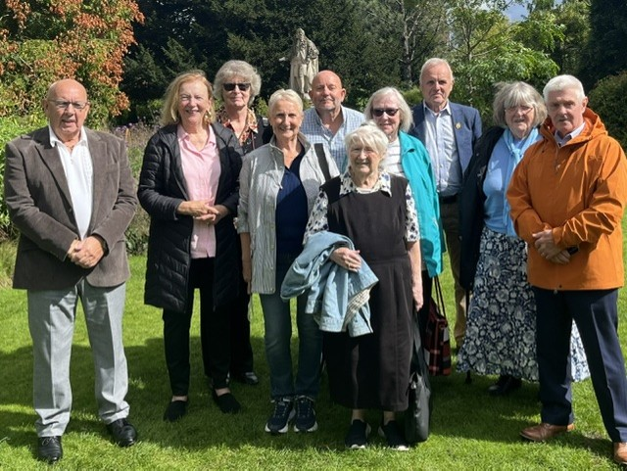

“Relaxing At The Chelsea Physic Garden”

THE ROLL CALL OF REMEMBRANCE WORKERS

Active (as at 31 Aug 2025)  Mr Paul Barnsley  Ms. Karen Barrett  Ms. Jane Bowley  Ms. Laura Bowley  Mrs Betty Brack  Mr Michael Bunce  Mr Lawrence St Clair Fenty  Major (Rtd) Henry J Gardiner  Mrs Susan Gardiner  Mr Sachin Handa  Ms. Pat Hooper  Mrs Dorothy Howlett  Mrs Pat Hutton  Mrs Georgina Kelly  Mr Adrian Kench  Mrs Sandra Kench  Mr Gary Lee  Mrs Sue Leyland  Miss Naomi Manikkawasagan  Mrs Shantini Manikkawasagan  Ms. Myriam Marriott  Miss Toni McCabe  Mr Robert McCall  Miss Donna Mills  Mr Derek Mitchell | Ms. Brenda Moreton  Ms. Wendy Morris  Mr Patrick Mulhern  Ms. Marian Roiser  Mr Martin Roscoe  Mr Stephen Sambrook  Mr Michael Sims  Mrs Pat Slaven  Ms. Avril Smith  Mr Steve Smith  Mr Cyril Victor  Mrs Patricia Walton  Mr William Watkins  Mrs Jill Wickenden  Honorary  Ms. Anita Campbell  Mrs Jane Cooper  Mrs Pat Culver  Mrs Sue Cypher  Mrs Margaret Donovan  Miss Jane Gully  Miss Catherine MacMillan  Mrs Eileen McKinder  Ms. Anne Rollings  Ms. Maureen Strange

WHERE OUR REMEMBRANCE WORKERS VOLUNTEER

AGE UK
Autism Family Support
Buckingham Community Hospital
Chelsea & Westminster Hospital
Colchester General Hospital
Colchester Food Bank
CWGC
Florence Nightingale Hospice
Guy's Hospital
Oxford Asylum Welcome
Scrap Store Wandsworth
Shopmobility Wandsworth
Sport For Confidence
St George's Hospital
St Mary's Hospital
St Thomas' Hospital
The Company of Nurses
The Willen Hospice Shop
The Royal British Legion
The Royal Hospital Chelsea Infirmary
The Salvation Army
Waddesdon Manor Wildlife Trust
Woolverton Community Foodbank

Thank you so much for all the generous, philanthropic, support from our individual donors, trusts, and foundations.

The William Brake Foundation
The National Lottery Community Fund
The Adint Charitable Trust
The Barratt Homes Community Fund
The Robert Clutterbuck Trust
Ms Eileen MacKinder

OUR WONDERFUL DONORS AND SUPPORTERS

POLICIES AND STATEMENTS

Investment Policy
The Council (the formal name for our body of Trustees) reviews the investment performance of its portfolio, as part of our Board meetings, at least three times per year. At one of these meetings, a representative from CCLA Investment Management Limited (CCLA) attends, gives a verbal briefing, and their written investment report is examined in detail. On the other occasions, a written brief is received prior to the meeting in order to inform our decisions. The charity's intention is to derive the maximum income possible in current economic conditions from its investments, and considers that a minimum of a four-monthly review will satisfy this intent.

Our portfolio is invested in two COIF Charity Funds, which are monitored and supervised for the benefit of participating charities by an independent board of individuals, with considerable investment, legal and other experience. As part of its responsible approach, the COIF Charities Investment Fund Board has formally agreed to consider social, environmental, and economic factors as part of the investment process. This three-fold approach encompasses firstly the Fund's exclusions, secondly a pro-active strategy with companies, and thirdly an active corporate governance policy.

Reserves Policy

The Council periodically reviews the need for, and the level of, financial reserves held by the charity. This review encompasses risk, the nature of the income and expenditure streams, the need to match variable income with fixed commitments and the nature of reserves.

In common with other charities, the League of Remembrance holds free reserves to ensure that our services can continue during an extended period of unforeseen reduced income streams, or increased expenditure.
Our reserves policy is set with particular reference to the financial risks facing the charity.
Our biggest risk is that our income, generated entirely from our Invested Reserve and through private donations, suddenly drops because of unforeseen factors beyond our control. In these circumstances, reserves may need to fund operating expenditure while the organisation is put back onto a stable footing.

The current review concluded that to allow the charity to be managed efficiently, and to provide a buffer for uninterrupted services if our donated income drops significantly, is that a Reserve which consistently generates a minimum dividend return of 50% of our average operating expenditure be maintained. Critically, this dividend is not determined by the value of our Reserve (something that has fluctuated between £1M and £1.9M over the last few years) but by the number of units held within our Reserve investment funds. Drawing down on this Reserve, therefore, carries a significant risk of reducing dividend returns, and a subsequent inability to cover critical operating costs.

We also concluded, however, that our Reserve needs to be drawn down upon as necessary to meet the ever-increasing need of our volunteers at hospitals, hospices, and other social institutions; and those other organisations/individuals we support. This will involve risk, but risk that we believe is manageable with regular scrutiny and oversight.

Risk Management Policy

Risk is recorded on a Register, assessed at each of our Council Meetings, and adequate measures implemented to accept, reduce, transfer, or terminate any risks to which the charity is exposed. This assessment includes financial risks associated with the charity's investments which are addressed at each of our meetings.

Trustees Responsibility Statement

The Trustees are responsible for preparing the Trustees’ Annual Report and the financial statements in accordance with applicable law and United Kingdom Accounting Standards (United Kingdom Generally Accepted Accounting Practice), including FRS 102 “The Financial Reporting Standard applicable in the UK and Republic of Ireland”. The law applicable to charities in England and Wales requires the Trustees to prepare financial statements for each financial year which give a true and fair view of the state of affairs of the charity, of the incoming resources, and of the application of resources of the charity for that period.

- In preparing these financial statements, the Trustees are required to:

- Select suitable accounting policies and then apply them consistently;

- Observe the methods and principles in the Charities SORP;

- Make judgements and estimates that are reasonable and prudent; state whether applicable accounting standards have been followed;

Prepare the financial statements on a going concern basis unless it is inappropriate to presume that the charity will continue in business.

The Trustees are responsible for keeping proper accounting records that disclose with reasonable accuracy at any time the financial position of the charity and enable them to ensure that the financial statements comply with the Charities Act 2022 and the Charity (Accounts and Reports) Regulations 2015. They are also responsible for safeguarding the assets of the charity and hence for taking reasonable steps for the prevention and detection of fraud and other irregularities.

This report was approved by the Trustees on XXXXXXXX, and signed on their behalf by:

Geraldine Norris DL
Chair

