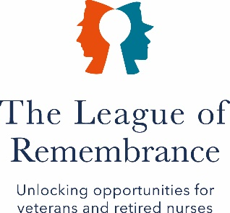
THE LEAGUE OF REMEMBRANCE NEWSLETTER

AUTUMN/WINTER 2024/2025 EDITION 2
TOPICS

INTRODUCTION
OUR ANNIVERSARY
MEET OUR REMEMBRANCE WORKERS
PARTNERING
MEET OUR TRUSTEES
EVENTS

INTRODUCTION BY OUR CHAIR, GERALDINE NORRIS DL
I hope that you all enjoyed a very Merry Christmas, and are looking forward to 2025. This year marks the 110th anniversary of our formation, a long, and very successful and rewarding journey. We are considering how best to celebrate this occasion and will have more detail by the time of the next AGM. Some of our very interesting history is detailed further on in this newsletter.

Turning to the AGM, it will again be held in the Union Jack Club on Thursday 3rd April, followed by the Spring Lunch. More detail will follow in due course but, in the meantime, if you have anything you wish to raise or discuss at the Meeting, then please let Rob or Susan know.

We have made more progress on partnering since the update in our first newsletter, including entering in to a 5-year partnership with Level Best, please rest assured that you, our Remembrance Workers, are, and will remain, at the forefront of our work.

OUR ANNIVERSARY

Formed in 1915, under the guidance of Princess Beatrice, ably supported by Ethel McCaul RRC, we have since undergone many changes in our approach and support, all underpinned, however, by the principle that the people we support are always our priority, and it is they who are the reason that we exist.

Originally comprised of wonderful volunteers who supported the Central War Hospital Supply Depots making medical supplies and clothing for those in the trenches, we turned to supporting the widows of the fallen from 1918 onwards, who replaced our volunteers, in return for which we provided welfare, training and financial support. Over the years they produced many hundreds of thousands of articles for our hospitals and infant welfare centres, latterly in our own workshops. We called these volunteers Remembrance Workers, a name that remains to this day, and which was instigated so that we might never forget the sacrifices of those who fell in the service of their country.

Later on, when the need for this type of support diminished, we turned to supporting volunteers who delivered services in hospitals, hospices, and other social institutions, something that remains to this day.

And now, as we begin our 110th year we are in the process of adapting our model once again, to make us ready to meet the challenges of the future.

The following images give you a flavour of our wonderful history over the last 109 years.
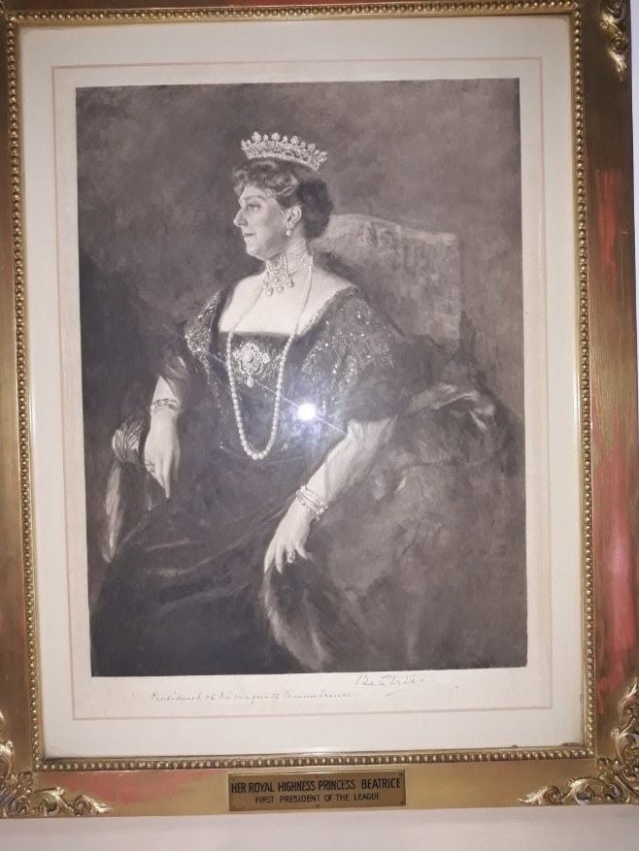

1915 – FOUNDED BY PRINCESS BEATRICE
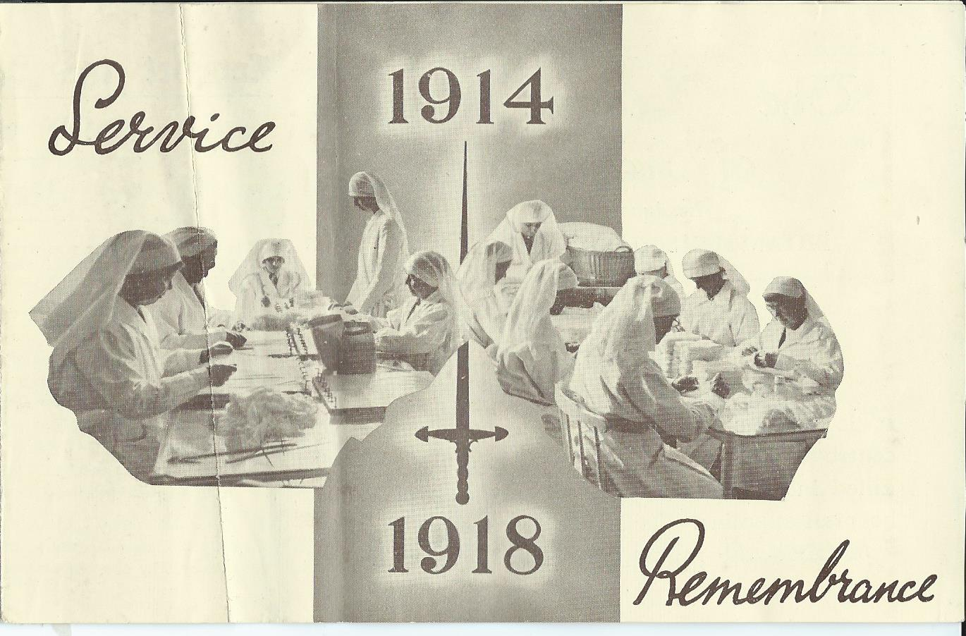

1918 – SUPPORTING THE WIDOWS OF THE FALLEN

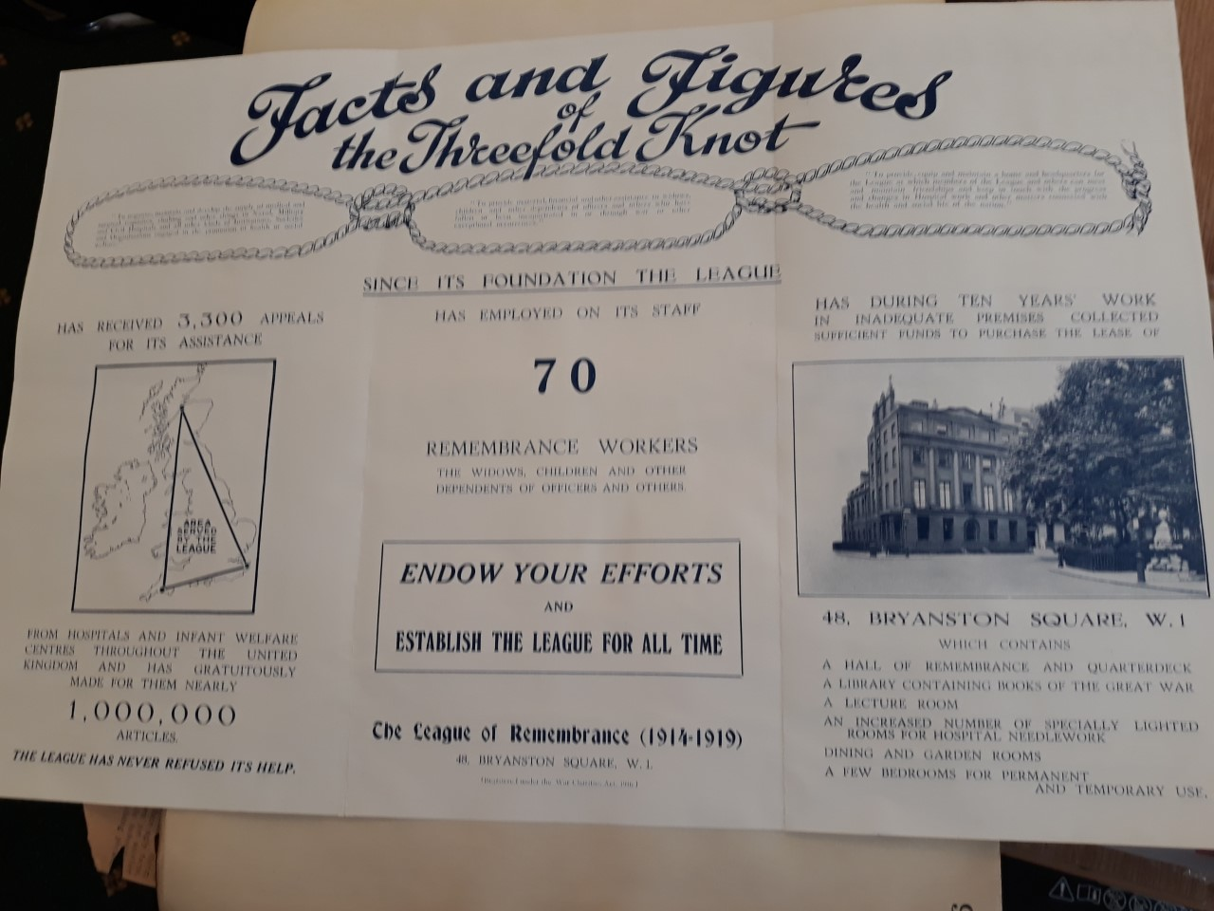

1929/30 – OUR ACHIEVEMENTS
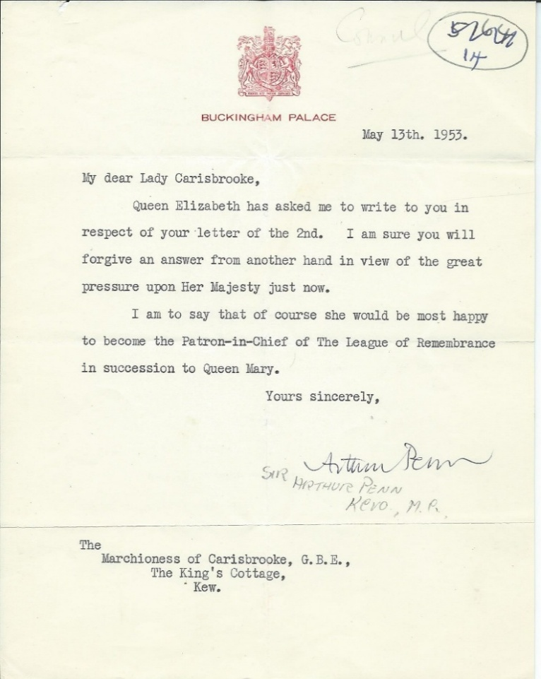

1953 - OUR WONDERFUL QUEEN MOTHER JOINS US

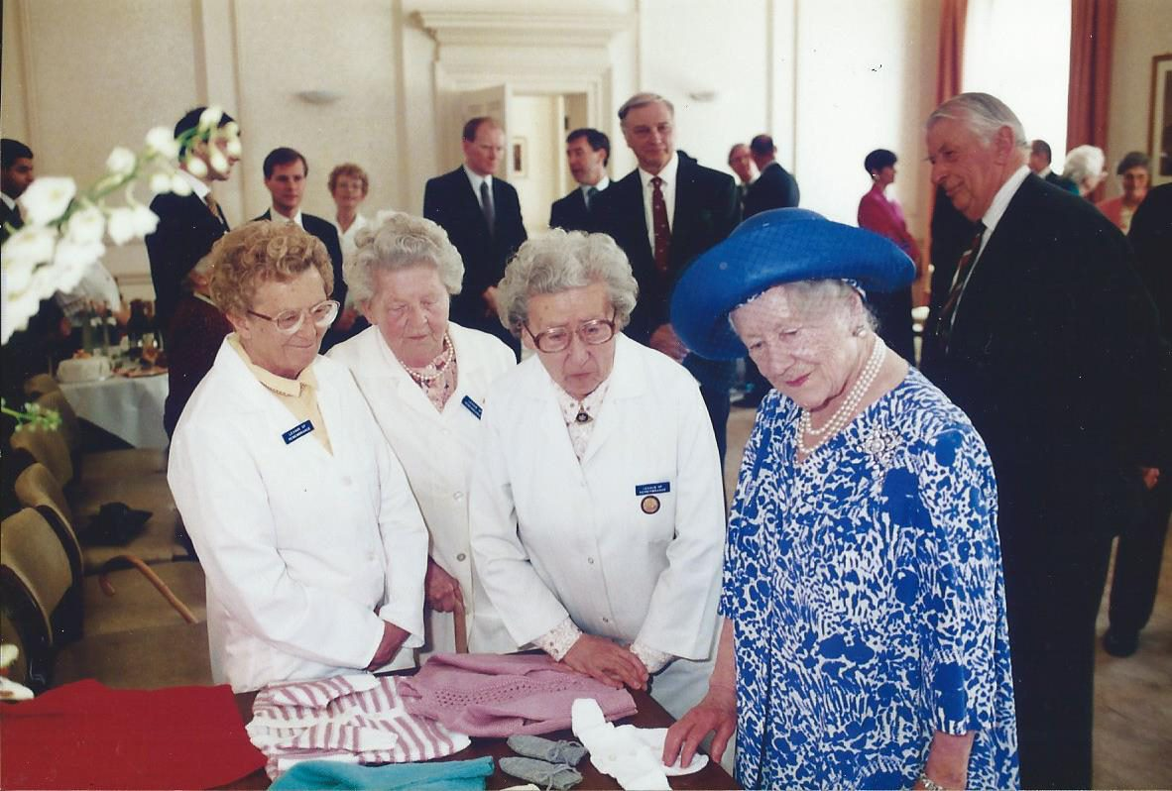

A VISIT BY HER MAJESTY THE QUEEN MOTHER
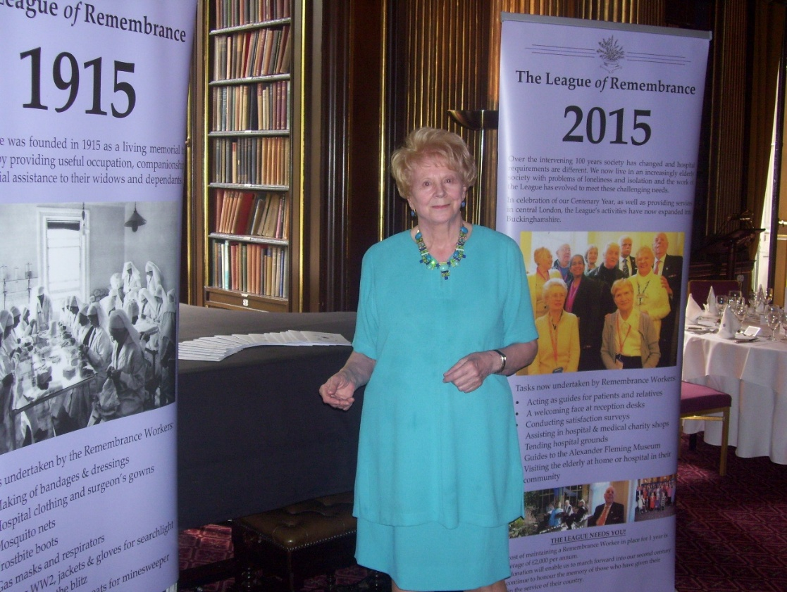

2015 – BETTY CELEBRATING OUR 100TH ANNIVERSARY

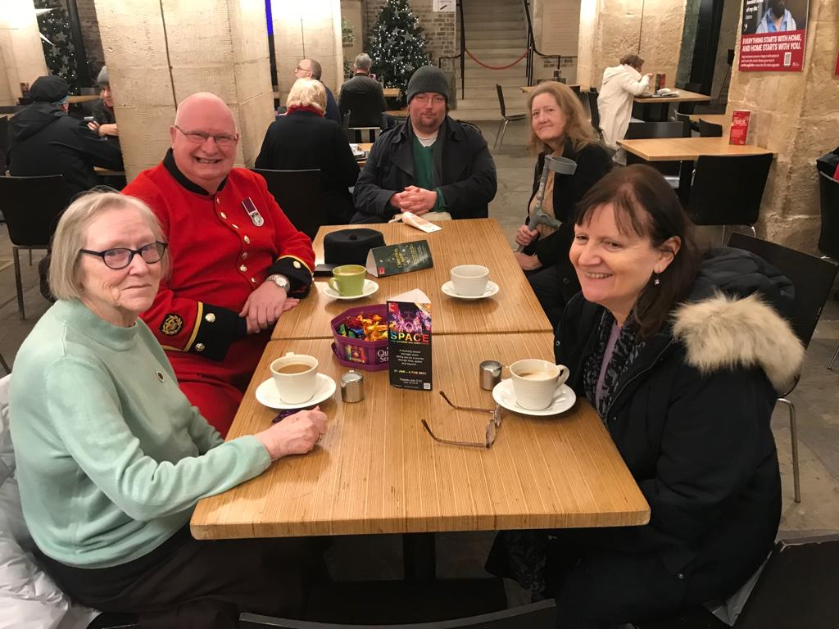

2023 – CATCHING UP WITH OLD FRIENDS
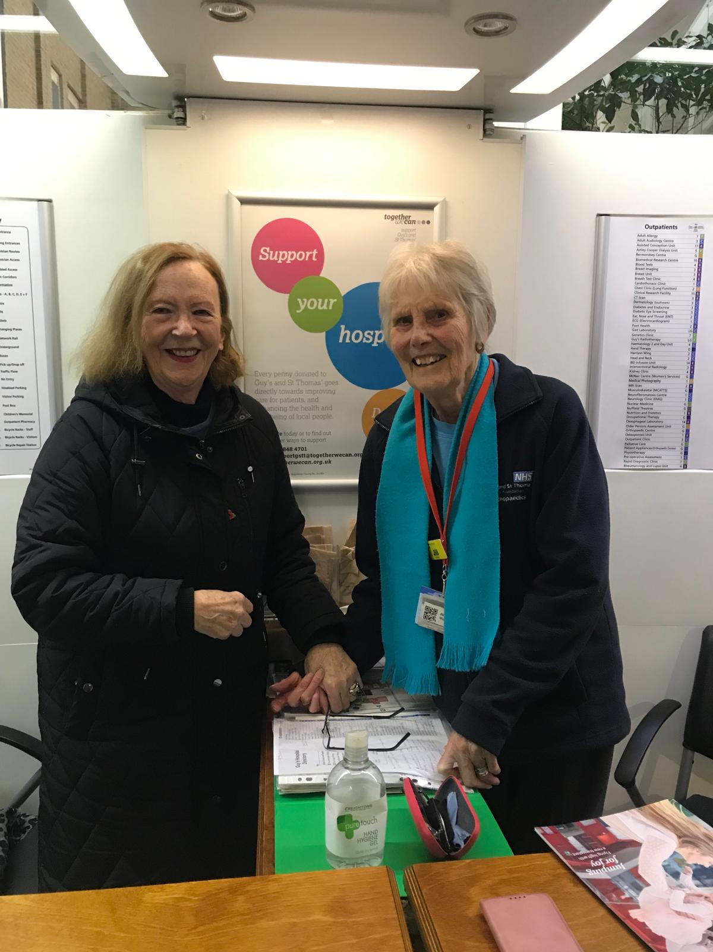

2024 – TWO OF OUR STALWARTS
MEET OUR REMEMBRANCE WORKERS
Gary
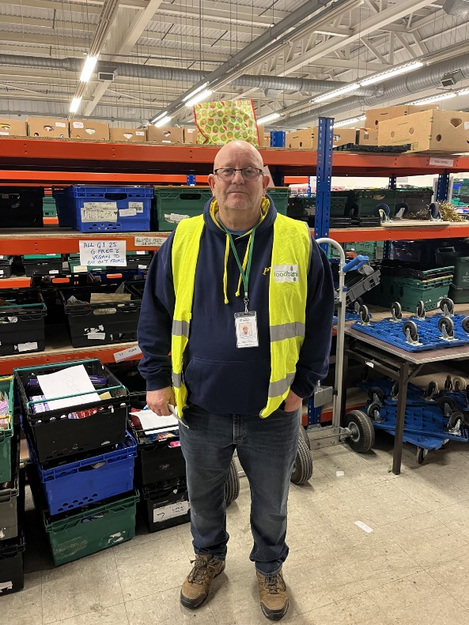
Having no idea what I wanted to do in life, I joined the military in 1977 and spent three days at the Sutton Coldfield assessment centre before being sent to Catterick in North Yorkshire. My unit was the Royal Corps of Signals and post basic training I went on to become a radio operator. During the fireman’s strike I was sent to Chester Le Street and became one of the crew on a Green Goddess fire engine. One memorable incident was at a working men’s club and whilst tackling a ferocious fire upstairs turned round to find a lovely lady stood behind us with a tray of hamburgers.
My first posting was to RAF Gutersloh in Germany, the first of many tours in BAOR which included armoured and infantry brigades as well as air support with the RAF. I completed three different tours in Northern Ireland, The Maze Prison, Lisburn Garrison and Armagh. After seventeen years and with the rank of Staff Sergeant, I took phase two redundancy to become a civilian. This was a difficult transition period for me but adapted by using the skills of my military trade to become a Communications Officer with Essex Police. During this time I worked during my rest days at Jaques Hall with young children in care for various reasons. I found it rewarding helping youngsters who needed support and understanding to get them ready for the outside world.
After eight years with the Police I needed a new challenge and became an Emergency Medical Technician with the London Ambulance Service and after training honed my skills in and around the Tottenham areas. Once again this was a challenging time dealing with an increase in shootings and stabbings.
My wife and I do not have children so we decided to become Respite Foster Carers for children with severe and profound disabilities. They were aged from toddlers up to teens and gave us some emotional and happy times. I was the main carer and during our panel was asked why I wanted to foster? My reply was simple, during my first posting both my troop Sergeants supported my monthly requests to expand my training and allowed me to work with other units and undertake recreational activities such as parachuting and skiing.
Eighteen years after joining the London Ambulance Service I retired and was invited to look after a farm in Bordeaux which I found very therapeutic.
Unfortunately, Covid hit the world and I was asked to return to front line service, this time with East of England. This was a very challenging and at times upsetting dealing with very sick patients.
In October of 2024 I finally retired from front line service and have now taken a volunteering position at Colchester Food Bank, which I am enjoying.
I became involved with the League of Remembrance and have supported military veterans in a variety of ways which have included assistance completing assessment forms to obtain disability payments to just simply having a talk over coffee. It is a very rewarding charity and I receive full support from them for any assistance or requests I may ask for. Should you have any free time and would like to assist veterans I would highly recommend you contact the League and offer your support.
PARTNERING
Our last Newsletter provided a flavour of what we have achieved to date as part of our emerging strategy. Since then, we have made further progress as follows:

Level Best

A charity based in Colchester, its focus is on training young disabled adults, primarily suffering from autism, in catering and service skills, with the objective of getting them into paid employment post-training. We have now entered into a 5-year partnership with them, as part of which we will provide funding for 20 training placements.

High Ground

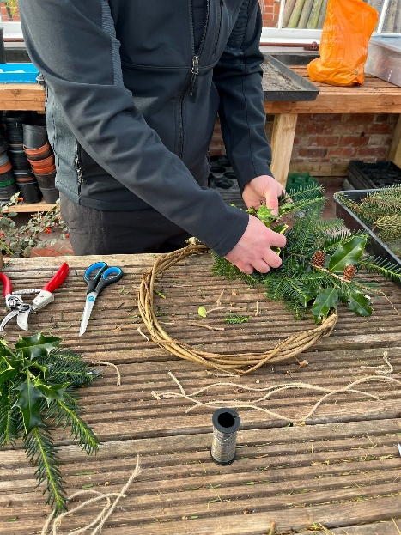
A charity that supports both serving men and women, and veterans, through the provision of land-based training and employment opportunities, we provided funding to enable injured residents at the Defence Medical Rehabilitation Centre (DMRC) to participate in a Xmas Wreath Making project, designed to improve both skills and mobility, and to provide the necessary adaptive tools to enable participation by all..

Warrior Equine

This charity supports those veterans suffering from PTSD and stress by providing equine therapy to ease their stress and anxiety and give them confidence. Following a visit, where we spoke to veterans, and saw the therapy being delivered, and what a positive outcome it achieved, we provided a grant to enable three veterans, male and female, with one being drawn from each of the three Services, to attend a therapy week.
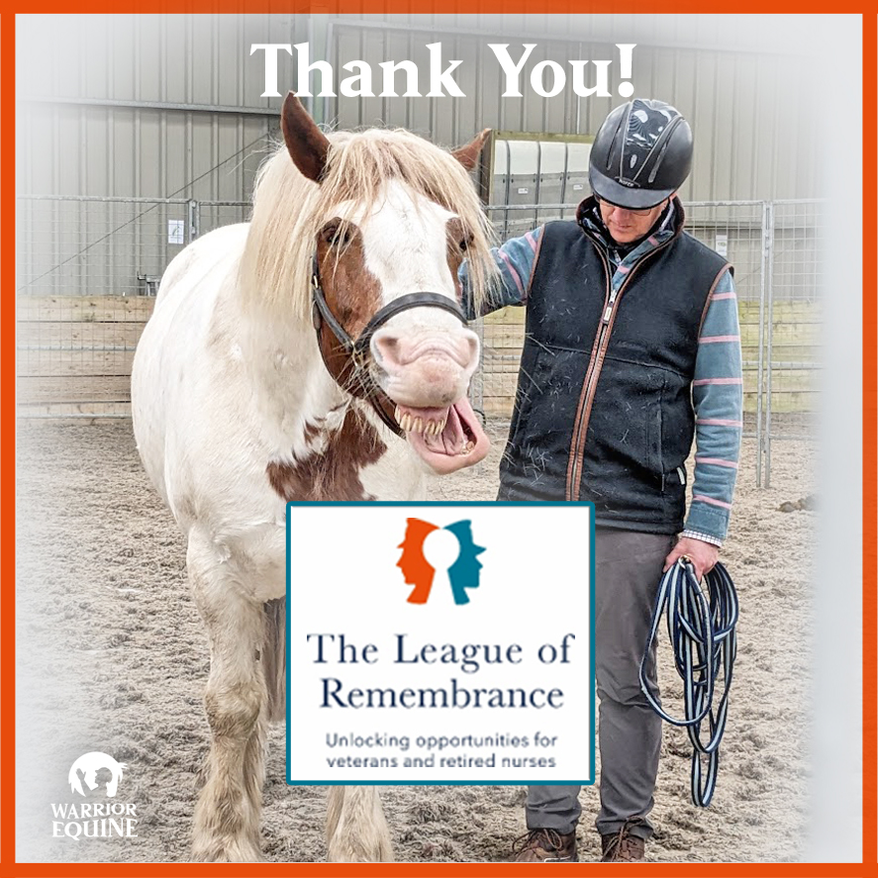

Sport For Confidence

This inspiring charity gets disabled adults into sporting and physical activity in order to improve their confidence, and mental and physical wellbeing. After a day spent participating in activities with their beneficiaries and volunteers, The League of Remembrance awarded a grant to fund training for disabled volunteers; and for the provision of a ‘ramp’ to enable a very-severely disabled young lady to participate in activity.

MEET OUR TRUSTEES
Chris Eberhardie
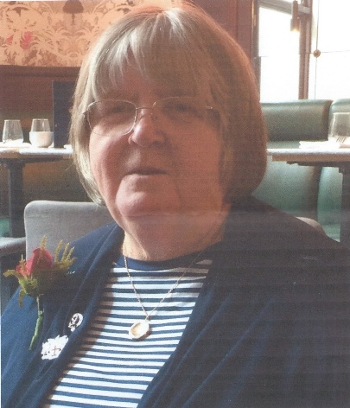
Chris is a retired general and neuroscience nurse. She gained experience in various parts of the UK and Belgium, and has also worked with national and international nursing organisations. In 1979, Chris was elected as the first Chair of the European Association of Neuroscience Nurses, and was elected Vice-President of the World Federation of Neuroscience Nurses. Her research has centred on nutrition support in Traumatic Brain Injuries.
Chris joined the QARANC Reserve in 1970, and for most of the next 30 years was in the Army Neurosurgical Team. She was awarded the Territorial (Efficiency) Decoration in 1982, the First Clasp in 1988, and the 2nd Clasp in 1994.
On retirement, Chris lived in France until the death of her husband in 2015, at which point she returned to England to start a new career in the history of military medicine, and taking up volunteering in military charities.

EVENTS

2025 AGM and Spring Lunch

This event will again be held at the Union Jack Club, on Thursday 3rd April 2025. In a change from last year, the event will take place on the ground floor in the McIntosh Room, the one we used prior to Covid. Susan will distribute the details in due course, and we hope that as many of you as possible will be able to join us.

2025 Summer Outing

Planning is already underway for this, to take place in early September. Initial thoughts are that we could visit the Chelsea Physic Garden, established by the Worshipful Society of Apothecaries of London in 1673, but if you have any other suggestions then please do let us know.


and finally, please send any suggestions for improvement, or articles/photos for inclusion in the next Newsletter, to:

Email Us: info@leagueofremembrance.com
Call us: 07936 505664
Post To Us: 95 Horseferry Rd, London, SW1P 2DX

